CHAPTER 10: Transferring and transforming energy
Worksheet 10.4

Light energy

Answers
1. The incandescent light bulb
The diagram shows an incandescent light bulb.
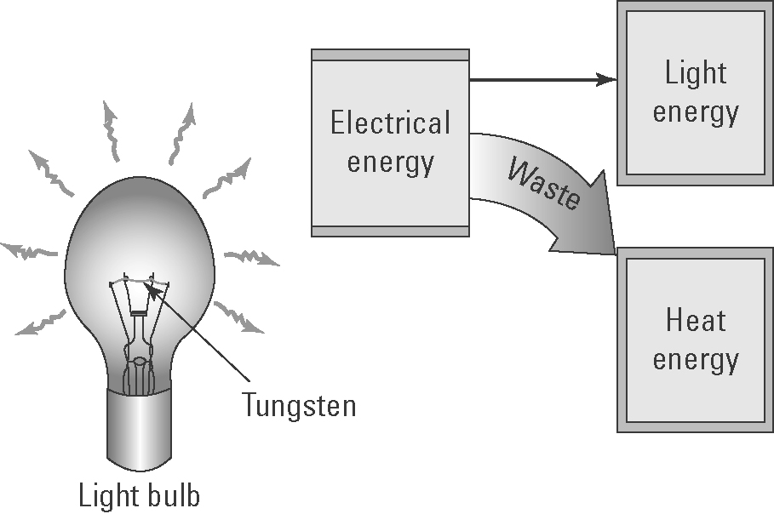
(a) Explain how an incandescent light bulb generates light.
Incandescent light bulbs contain a filament made of tungsten that is luminous or glowing due to the high temperature of the wire as the current flows through it.

(b) Insert the following words in the boxes in the diagram:
heat energy, electrical energy, light energy
(c) Explain why these light bulbs are not energy efficient.
They are not energy efficient as most of the energy released is heat rather than light.

2. Measuring reflected light
The diagram below shows the procedure used by a student to measure the intensity of reflected light from various materials and compare it with light reflected by a normal mirror.
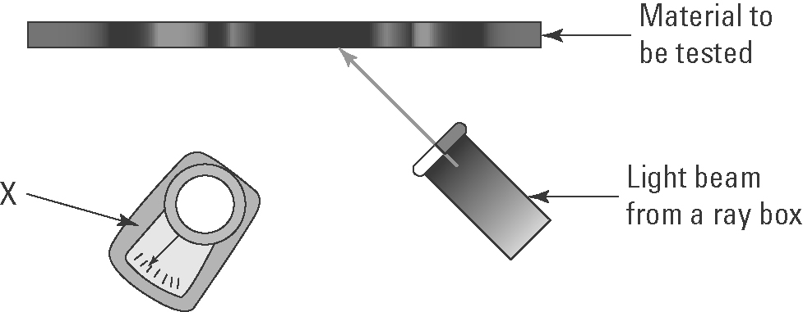
X: light meter
(a) Identify the measuring device X.
(b) Why is a normal mirror also tested?
It acts as a control to allow a comparison with the other test materials.
(c) Identify the variables that need to be controlled.
Distance of light source from the materials to be tested; angle of light incident on the material; the same light meter; same ambient light.

(d) The following materials were tested: shiny white cardboard, dull black cardboard and shiny black cardboard. Predict which cards will reflect the:
(i) most light energy ..........................................
Dull black cardboard
Shiny white cardboard
(ii) least light energy ..........................................

